

The Surveyors Associated With the

Surveyor General's Office in Oregon in the Contract Era, 1851-1910

1.0

Published by Winter Creek Ranch 2022 Copyright Jerry C. Olson 2022

The General Land Office, under the Surveyor General of Oregon, provided the original surveys of the public domain, allowing for entry and settlement.

The Office was staffed by Surveyor Generals, Clerks, Draftsmen, and sometimes Examiners. They contracted the surveys to private Deputy Surveyors from 1851 until 1910 when the system of direct employees took over. The contractors also provided Mineral Surveys, Donation Land Claim Surveys, Homestead Entry Surveys, and surveys of Indian Reservations and Allotments.

General Land Office in Washington and Oregon

Short Biographies of the Surveyors (601 biographies) Photos of the Surveyors, Their Families and Tombstones Appendix including, Details, Graves, Crewmen, Mineral Surveyors, DLC Surveyors, and Signatures

2600+ pages

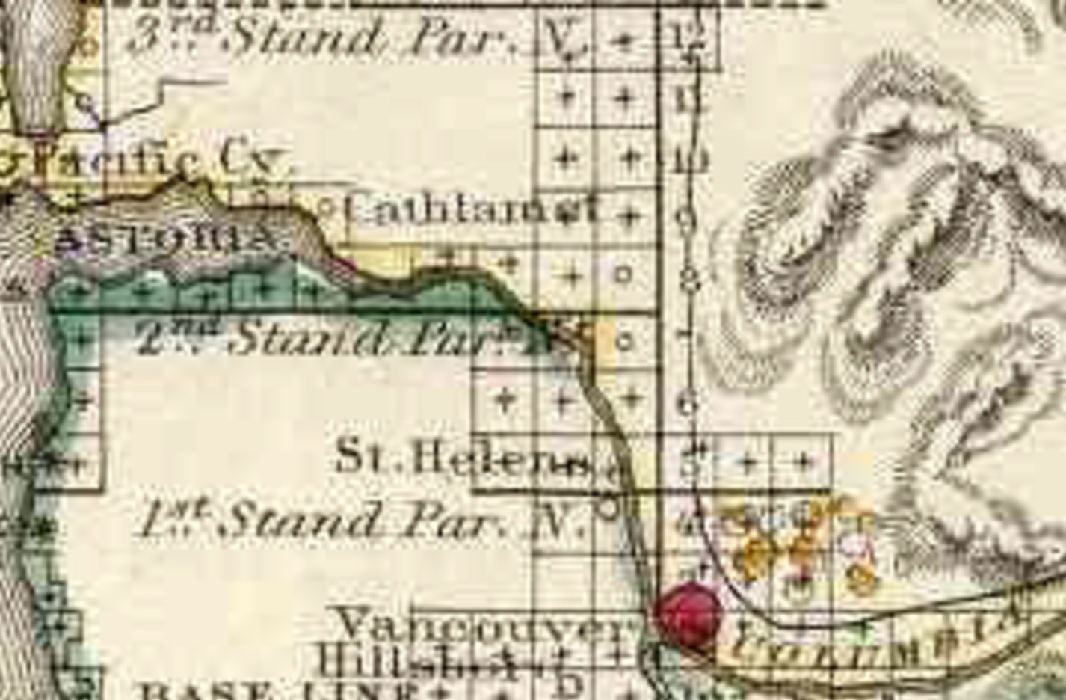

**Surveying**

**South of the River**

1.0

by Jerry C. Olson